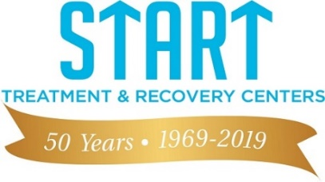
START Treatment and Recovery Centers | 937 Fulton Street Brooklyn NY 11238 Phone: 718-260-2928

February 1, 2020

Greetings!

START Treatment and Recovery Centers cordially invites you to attend our 50th Anniversary Gala. This year is a hallmark celebration, “50 Years and Counting” on Wednesday, May 13, 2020. The Gala will be held at the beautiful Prince George Ballroom in lower Manhattan. There will be cocktails, dancing, dinner, guests of honor and so much more. For more information, you can visit our website: http://www.startny.org.

START Treatment and Recovery Centers continues its commitment to individuals with substance abuse and mental health disorders in the community daily. On an annual basis, START assists thousands individuals with a myriad of substance abuse and mental health disorders, and we do it by providing them with the services, both clinical and therapeutic, that they need in order to get on the road to recovery. We are fortunate to be able to host the gala as a fundraiser for the START Community, to celebrate the important work that we have done to reduce the population living with substance abuse and mental health disorders in the community.

We are asking you to support START Treatment and Recovery Centers by purchasing a table or tickets to attend the Gala and/or purchase an advertisement in the 50th Anniversary Gala Program. The Program will showcase START’s hard work and commitment to the community over the last 50 years and many community agencies and businesses that provide a variety of services to residents of New York City. The Program will be distributed at the gala and thereafter. If you are unable to attend, would you be so kind as to donate a ticket for an individual to attend? All funds are 100% tax deductible and the money earned are earmarked to support Teen START, its adolescent mental health program, other START community-based services, and START’s fundraising capacity.

For your convenience, attached are the “50 years and Counting” supporting documents that can be returned via email to either rsuissa@startny.org or jbosco@startny.org. You can also visit the website at www.startny.org and use the donate button to purchase an advertisement in the program. Thank you for support of START Treatment and Recovery Centers. We look forward to celebrating 50 years with you in 2020! If you have any additional information, please contact Rachelle, External Affairs Officer, at 718-260-2928, or Josephine, External Affairs Officer at 718-260-2942.

Sincerely,

Marlene Heath
Chief Administrative Officer

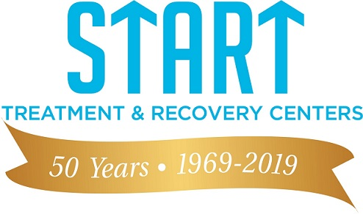
START Treatment and Recovery Centers | 937 Fulton Street, Brooklyn NY 11238 | Phone: 718-260-2928

START: 50 Years and Counting

Program Advertisements

Diamond Level - Full Page Ad $10,000 _____________
Platinum Level - 1/2 Page Ad $7,500 _____________
Gold Level - 1/4 Page Ad $5,000 _____________
Silver Level - 1/8 Page Ad $2,500 _____________
Bronze Level - 1 Liner $1,000 _____________

Total Enclosed: _____________

Name: _______________________________________________________________________________
Contact Person: _______________________________________________________________________
Address: _____________________________________________________________________________
City: _______________________________ State: __________________ Zip: ______________________
Day Phone: _______________________________ Night Phone: _______________________________
Fax: _______________________________ Email: _______________________________

Note: All Advertisements Must be Camera Ready

Deadline: Camera Ready Advertisements must be received by March 15, 2020.

Please make check payable to: START Treatment and Recovery Centers along with this completed form.
Mail: ATTN: 50 Years and Counting 937 Fulton Street Brooklyn NY 11238. Completed form may also be emailed to either rsuissa@startny.org or jbosco@startny.org. For any questions, please contact Rachelle Suissa, External Affairs Officer, at rsuissa@startny.org/ 718-260-2928 or Josephine Bosco, External Affairs Officer at jbosco@startny.org/718-260-2942.

START Treatment and Recovery Centers | 937 Fulton Street, Brooklyn NY 11238 | Phone: 718-260-2928

Donation: $250 Per Ticket
Table of 10 seats: $2,500

Name of Organization: __________________________________________________________________

I will attend with _____________ guests and their names are listed below.

1. ______________________ 6. _______________________

2. _______________________ 7. _______________________

3. _______________________ 8. _______________________

4. _______________________ 9. _______________________

5. _______________________ 10. _______________________

I cannot attend. Here is my donation of: $ __________.

Please make check payable to: START Treatment and Recovery Centers along with this completed form.
Mail: ATTN: 50 Years and Counting 937 Fulton Street Brooklyn NY 11238. Completed form may also be emailed to either rsuissa@startny.org or jbosco@startny.org. For any questions, please contact Rachelle Suissa, External Affairs Officer, at rsuissa@startny.org/ 718-260-2928 or Josephine Bosco, External Affairs Officer at jbosco@startny.org/718-260-2942.

